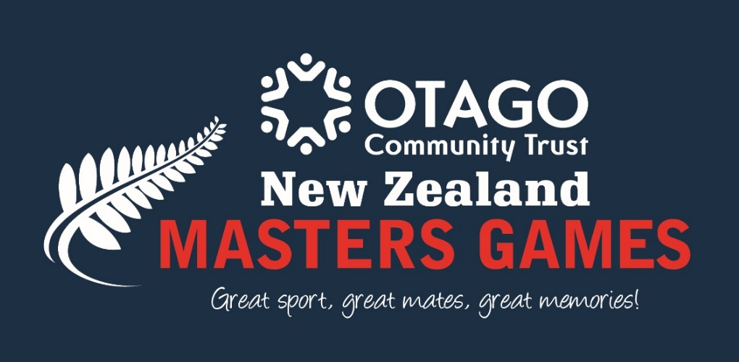

PLEASE NOTE:
At the end of October, the government released the latest COVID-19 Response tool, the COVID-19 Protection Framework.
This framework introduces the use of a Vaccine Pass as a requirement for large events at both the Green & Orange levels. Keeping our volunteers, staff, entrants, and stakeholders safe is very important to us, and the Masters Games team will support the governments vaccination certificate mandate.
Under this new framework, the New Zealand Masters Games will be able to take place as long as we ensure all staff and members of the public attending the event are fully vaccinated. As such, following the Government mandate, production of a Vaccine Pass will be a mandatory condition of entry for all entrants and supporters

ANZAS Ice Figure Skating Competition

Dunedin New Zealand

Saturday 5 & Sunday 6 February 2022

Hosted by
This event is sanctioned by the NZIFSA

Dunedin Ice Stadium 101 Victoria Road St Kilda South Dunedin

Contact: Sue Hoseit Mbl: 0274438123 Email: sue.abr@xtra.co.nz
. ANZAS Ice Figure Skating Competition
Dunedin New Zealand

Adult Competition for Men, Ladies, Pairs, Ice Dance, Stroking and Synchronized Skating
Organised by the Dunedin Ice Skating Club in Dunedin New Zealand

Special Requirements:
- The NZMG ANZAS Ice Figure Skating Competition 2022 will be conducted in accordance with the NZIFSA Constitution and Regulations, and this Announcement.

- If there is a conflict between pertinent ISU Regulations or Communications and provisions set forth in this Announcement, the provisions in the Announcement govern.

- Participation in the NZMG Ice Figure Skating ANZAS Competition 2022 is open to all skaters who belong to a club affiliated to an ISU Member Federation (hereafter called “Member”), as per ISU Rule 107, paragraph 14, and qualify with regard to eligibility, according to ISU Rule 102, provided their ages fall within the limits specified in this Announcement and they meet the participation requirements.

- All New Zealand skaters must be a member of an NZIFSA affiliated club or non-resident guests and must be eligible persons as per NZIFSA Rule 103 and meet the requirements of NZIFSA Rule 202

- Professional skaters may only compete in grades Silver & above

- Age of participants as at 1 July 2021

- Competitors may compete in a maximum of 3 events plus Synchro Team/Skills event, and Creative Performance

Awards: Will be presented for 1st, 2nd & 3rd places in each event at the conclusion of each day

Judging: The International Skating Union Judging System (IJS) will be used for all NZIFSA grades and all additional dance and interpretive events. For all other grades placings will be determined by majority opinion of the judges.

Entry Deadline:
Skaters must enter on NZMG online at www.nzmg.org.nz this indicates the events and grades you will enter. The age category will be determined by your age entered in the entry form and in accordance with the following Age categories.

Age categories for Ladies and Men Free Skating events:
Class I skaters born between 1st July 1986 and 30th June 2003
Class II skaters born between 1st July 1966 and 30th June 1986
Class III skaters born on or before 30th June 1966
Age category for Dance and Pairs Events is determined by the youngest skater’s age.

The “Planned Program Content Sheet” and the “Competition Music Information” forms contained in this document must be sent to Sue Hoseit Email sue.abr@xtra.co.nz

Changed PPC or Competition Music Information forms must be handed in to the organiser.

Registration Fee

The entry fee must be paid to NZMG:
- Registration to Masters Games varies as detailed and gives you access to other sports and to the Games Venue (Party Town)
- NZMG Supporter (non competitor) - $45 Available from 20 August
What do you get for your Supporter Fee?
  - Souvenir Games programme handbook
  - Exclusive access to nightly entertainment at the Games Village
  - Entry to Welcome Ceremony and Farewell Party
  - Quality souvenir bag
  - Free entry to all Games sports venues

- NZMG Registration Fee
What do you get for your Registration Fee?
- Opportunity to participate in one or more national standard professionally organised sport competitions
- Souvenir Games programme handbook
- Exclusive access to nightly entertainment (9 nights) at the Octagon Hub
- Entry to Welcome Ceremony and Farewell Party
- Quality souvenir bag
- Free entry to all Games sports venues
- Medals for place-getters in qualifying events

- NZMG Early Bird Registration $70 - Entries accepted until 30 November 2021

- NZMG Standard Registration $100 - Entries accepted from 1 December 2021 until 11 January 2022

- NZMG Late Registration $130 Entries may be accepted from 12 January 2022

- ANZAS Ice Figure Skating Events:
- $65 per person per singles event
- $50 per person per dance or pairs event
- Synchronized Team or Skills event $25 per team member
- Creative Event $25 per team member

Closing Date for Entries: Closing date is 21 Jan 2022.
Should NZMG be cancelled due to Covid 19, regulations, an alternative event will be considered and advised as soon as practical.
Please note the date for entering Stroking has been extended to 31 January, please register through Sue Hoseit as sue.abr@xtra.co.nz

MUSIC DETAILS AND PLANNED PROGRAM CONTENT FORM
Competitors need to provide the details of the music they are skating to. For Pattern Dance, if using the supplied ISU or non-ISU tracks, please state which track. All competitors in Free Skating, Rhythm Dance, Free Dance, Synchronized skating must also submit for each program their planned program content (PPC) information. PPC not required for Interpretive Grades. Competitors must complete either the electronic form on the NZIFSA website or submit the Music and PPC Form with their entry. Changed PPC sheets must be handed in to the Accreditation desk at the time of registration for the information of the Technical Panel. Entries will not be accepted without a completed PPC, either hard copy or electronic.

MUSIC FILES
Music is to be sent via email to music4disc@gmail.com in MP3 format. Files MUST be saved with competitor’s grade, SP / FS / INT and full name eg: “Bronze Ladies II FS Jane Jones” by (21 January 2022).

ADULT GRADES

ADULT AGE GROUPS
Minimum Age 18 years as at 1 July 2021 – no maximum age limit.
Age categories for Bronze, Silver, Gold and Elite grades are divided up as per NZIFSA Rules & Regulations for Freeskate, Interpretive Pairs, Solo Dance and Dance events as detailed above
Once entries have been received, we will confirm age groupings for all other events.

Adult Interpretive, adult Freeskating & Pairs Freeskating Programs
All programs to be skated to music. Vocal music is permitted. No props are permitted.

ADULT INTERPRETIVE
The Interpretive programs will be judged only on the basis of the five Component Marks. The program should consist of skating moves selected for their value to enhance the skater’s interpretation of the music rather than for their technical difficulty. Skaters will be judged on their ability to interpret the music and develop a theme by using their skating skills.

Copper, Pewter, Bronze & Silver 1 Min 30 secs +/- 10 secs. Gold 2 Min 10 secs maximum.
Copper Interpretive (1st timers) | Pewter Interpretive | Bronze Interpretive | Silver Interpretive | Gold Interpretive
To Include Maximum 2 Jumps & 2 Spins | To Include Maximum 2 Jumps & 2 Spins | As per NZIFSA Rule 226.5 | As per NZIFSA Rule 226.5 | As per NZIFSA Rule 226.5

Adult Interpretive Pairs (open) | 1 Min 30 secs +/- 10 secs | To Include Maximum 2 Jumps, 2 Spins and 2 Lifts.

Adult Stroking
Not required to have passed any medal tests, however skaters holding tests must skate Pewter level or higher.

Stroking - Up to 4 skaters may be on ice at same time
All perimeter stroking will be performed in an anticlockwise direction around the rink.

Pewter | Forward Russian Stroking 1 circuit around rink perimeter with crossovers at each end.  Backward Russian Stroking 1 circuit around rink perimeter with crossovers at each end.  Forward Power 3 turns (Left or Right Foot) – ½ length of rink
Bronze | Five Step Mohawk Sequence – 1 length of rink  Alternating Forward Inside Three-Turns – across the rink  Alternating Backward Crossovers to Backward Outside Edges – 1 length of rink  Forward Power 3 turns – ½ length of rink on each foot
Silver | Forward Outside – Back Inside Three -Turns in the Field - ½ length of rink on each foot  Forward and Backward Free Skate Cross Strokes – ½ length of each  Eight step Mohawk - two sequences in each direction. Performed as a figure eight  Backward Power Three-Turns - three to five per circle in a figure eight pattern
Gold | Forward Outside Double 3 turns – 1 length  Backward Inside Double 3 turns – 1 length  Backward Power Circle – choice of direction  Inside Slide Chasse Pattern – 1 length

ADULT Freeskating Bronze, Silver, Gold & Elite
Requirements as per NZIFSA Rule 226.4
Bronze Freeskating | 1 min 40 secs +/- 10 secs | Maximum 7 Elements
Silver Freeskating | 2 mins +/- 10 secs | Maximum 8 Elements
Gold Freeskating | 2 mins 50 secs +/- 10 secs | Maximum 9 Elements
Elite Freeskating | 3 mins +/- 10 secs | Maximum 10 Elements

ADULT PAIRS FREESKATING
Requirements as per NZIFSA Rule 227.4
Bronze | Silver | Gold | Elite
2 mins +/- 10 secs | 2 mins 20 secs +/- 10 secs | 2 mins 40 secs +/- 10 secs | 3 mins 30 secs +/- 10 secs

Adult Solo Dance & Partner Dance

Partnership for Zinc & Copper can consist of male/female or female/female. All other grades must be male/female partnership. One person may partner up to 2 persons but may only receive one award.
Where a partnership spans different age groups the age of the youngest skater will be used to determine the category.

For Zinc, Copper, & Pewter Grades up to 2 couples or 4 dancers may be on ice at same time.

 | SOLO DANCE |  | PARTNER DANCE
Zinc | Dutch Waltz | Tango Canasta | Dutch Waltz | Tango Canasta
Copper | Tango Canasta | Golden Skaters’ Waltz | Tango Canasta | Golden Skaters’ Waltz
Pewter | Tango Fiesta | Swing Dance | Tango Fiesta | Swing Dance
Bronze (as / NZIFSA) | Tango Fiesta, | Willow Waltz | Willow Waltz | Foxtrot
Silver (as / NZIFSA) | Foxtrot | Paso Doble | Rocker Foxtrot | Starlight Waltz
Gold (as / NZIFSA) | Blues  (Gold & Elite) | Westminster Waltz  (Gold & Elite) | Viennese Waltz | Quickstep
Elite (as / NZIFSA) |  |  | Ravensburger Waltz | Quickstep

Synchronized Skills & Synchronized Teams

Synchro Skills  Adults 18+ | Adult Synchro  Teams 18+
8-16 Team Members  Up to 3 min 10 secs  Skated to music  No Test Requirements  Adults 18yrs & over | 8-16 Team Members  3 min +/- 10 secs  Skated to music  As per NZIFSA Regs  Adults 18yrs & over

CREATIVE PERFORMANCE

Teams of 4 – 16 Skaters - Duration: Up to a maximum of 3 minutes
Skaters may perform in a group of four but not more than 16 skaters.
Props and vocal music are permitted. Costumes should enhance the feeling created by the performance and reflect the meaning of the story or theme. No bobby-pins, feathers, or anything else that may fall to the ice and be hazardous to the skaters are allowed, a deduction will be taken.

PRACTICE ICE:
The official practice schedule will be sent to competitors. Additional practice ice will be available on Friday 4 Feb.
Prior to this, competitors can practice on DISC club ice times. Times to be advised, and will be published on Dunedin Ice Stadium Website – www.DunedinIceStadium.co.nz under “what’s on” and calendar. Or follow this link https://www.rectimes.app/dunedinicestadium/index/index Cost is a single session.

Please address all requests for information related to additional sessions to:
Sue Hoseit sue.abr@xtra.co.nz

TENTATIVE TIME SCHEDULE
Please note: This schedule is subject to changes!
Friday Jan 31 Unofficial Practice TBA
Registration
Saturday Feb 1 Official Practice 8.00am -11.00am
Competition 2.00pm – 6.00 pm
Official NZMG Opening Ceremony
Sunday Feb 2 Official Practice 8.00am -10.00am
Competition 10.00am – 1.00 pm

Evening dinner, drinks and entertainment at NZMG Games Village every night at the University Hub – heaps of fun until really late!!

NZMG - ANZAS Ice Figure Skating Competition

Dunedin New Zealand

5,6 February 2022

COMPETITOR MUSIC FORM
This form must be returned prior to the competition starting.

Please fill in clearly and email back to sue.abr@xtra.co.nz

For pairs and dance couples it is sufficient if one partner fills in this form
Competitor(s): | Club
Event:

Rhythm Dance/ Interpretive
1 | Name of Music:
 | Composer: |  |  |  |  |  | Duration of Music:
 | Orchestra: |  |  |  |  |  | Record Label / Number:
2 | Name of Music:
 | Composer: |  |  |  |  |  | Duration of Music:
 | Orchestra: |  |  |  |  |  | Record Label / Number:
3 | Name of Music:
 | Composer: |  |  |  |  |  | Duration of Music:
 | Orchestra: |  |  |  |  |  | Record Label / Number:
Free Skating / Free Dance
1 | Event
 | Name of Music:
 | Composer: |  |  |  |  |  | Duration of Music:
 | Orchestra: |  |  |  |  |  | Record Label / Number:
2 | Event
 | Name of Music:
 | Composer: |  |  |  |  |  |  | Duration of Music:
 | Orchestra: |  |  |  |  |  | Record Label / Number:
3 | :Event
 | Name of Music
 | Composer: |  |  |  |  |  | Duration of Music:
 | Orchestra: |  |  |  |  |  | Record Label / Number:

Signature:
Date:

NZMG - ANZAS Ice Figure Skating Competition

Dunedin New Zealand

5-6 February 2022
PLANNED PROGRAMME CONTENT FORM

Please complete and email back to sue.abr@xtra.co.nz

COMPETITORS NAME
CLUB
COUNTRY
CATEGORY
ELEMENTS IN ORDER OF SKATING
 | Rhythm Dance |  |  | Freeskating/Free Dance
1 |  |  | 1
 |  |  | 2
2 |  |  | 3
 |  |  | 4
3 |  |  | 5
 |  |  | 6
4 |  |  | 7
 |  |  | 8
5 |  |  | 9
 |  |  | 10
6 |  |  | 11
 |  |  | 12
7 |  |  | 13
 |  |  | 14
8 |  |  | 15
 |  |  | 16

Signature:
Date:

